Lynzay legois
free water skiing club
Adaptive and Able Body Water Ski Events in joint effort with The Aquaducks
Free and for Fun Fridays FAFF

FAFF adaptive Friday Jun 28th 2019, 12:00 p.m. to 5:30 p.m.
FAFF adaptive Friday July 26th 2019, 12:00 p.m. to 5:30 p.m.
FAFF adaptive Friday Aug 16th 2019, 12:00 p.m. to 5:30 p.m.
Ski lesson Sundays: from 4:00 p.m. to sunset by appointment
Always for free and for fun in memory of Lynzay… Adaptive, Beginners, barefoot, swivel, shoe ski, trick, and wakeboard… wet suits, and all required other equipment is provided
Donations are accepted and we are a 501(3)(c) non-profit organization.
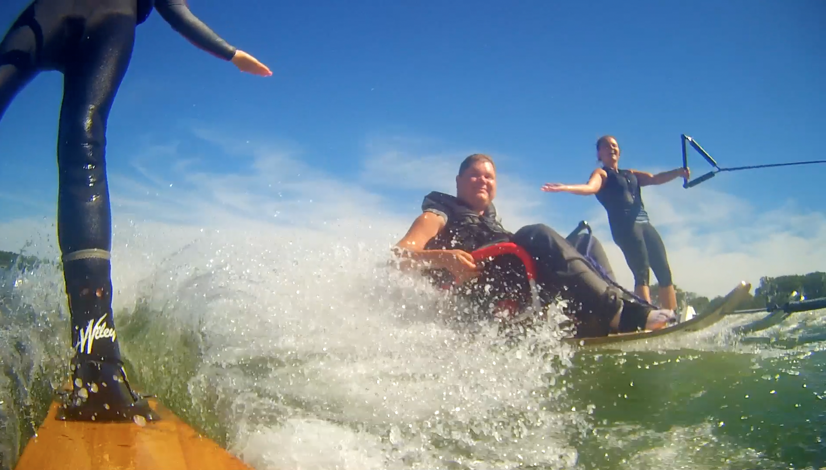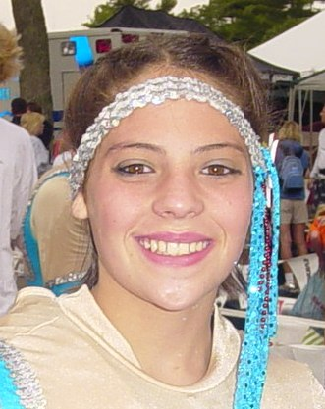
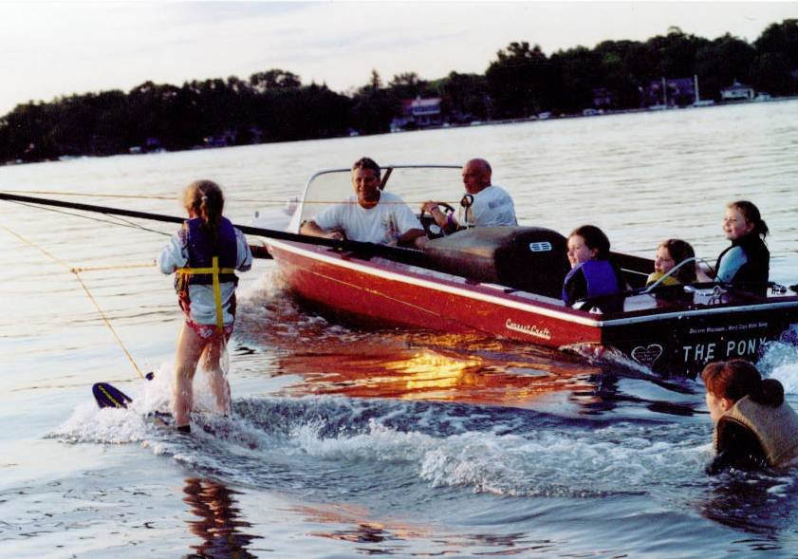
See waterski lesson videos on Lynzay’s website:
http://www.lynzay.org/
For more information or to schedule your free ski lesson
Call Rick and Denice Legois 262 497 8977
In Loving Memory of Lynzay Marie Legois
8/28/1992 – 12/12/2006 - Forever Missed…

